**Screenshots of Solution :Execise of Query optimization**

**Solution:**

CREATE PROCEDURE GetMaxQuantity()

BEGIN

SELECT MAX(Quantity) AS 'Get Max Quantity'

FROM Orders;

end;

CALL GetMaxQuantity();

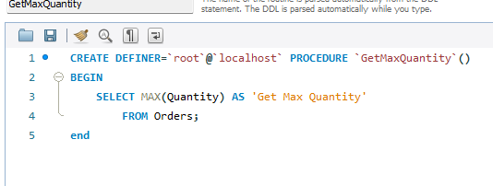

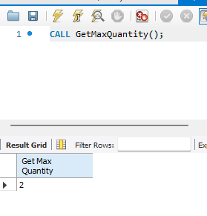

create a prepared statement called GetOrderDetail

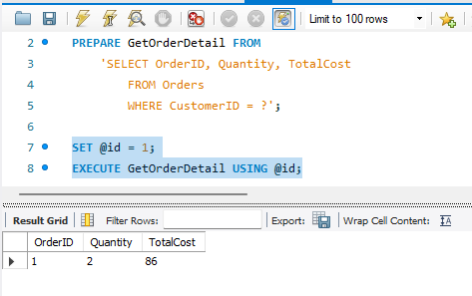

TASK 3 CREATE PROCEDURE CancelOrder

DELIMITER $$

CREATE PROCEDURE CancelOrder(

IN order_id INT,

OUT confirmation VARCHAR(255)

)

BEGIN

-- Delete the order with the specified ID

DELETE FROM Orders

WHERE Orders.OrderID = order_id;

-- Provide a confirmation message

SET confirmation = CONCAT('Order ', order_id, ' is cancelled.');

END$$

DELIMITER ;

CALL CancelOrder(3, @output_message);

SELECT @output_message AS ConfirmationMessage;

